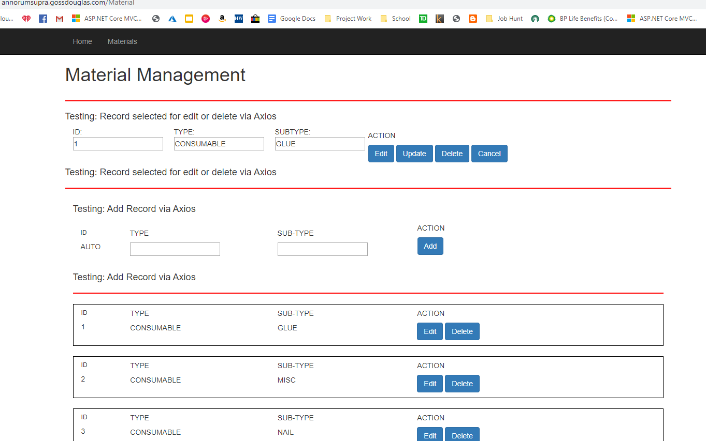

Jquery detects that event. This is the basis for my inline editing.

When a record row is selected…

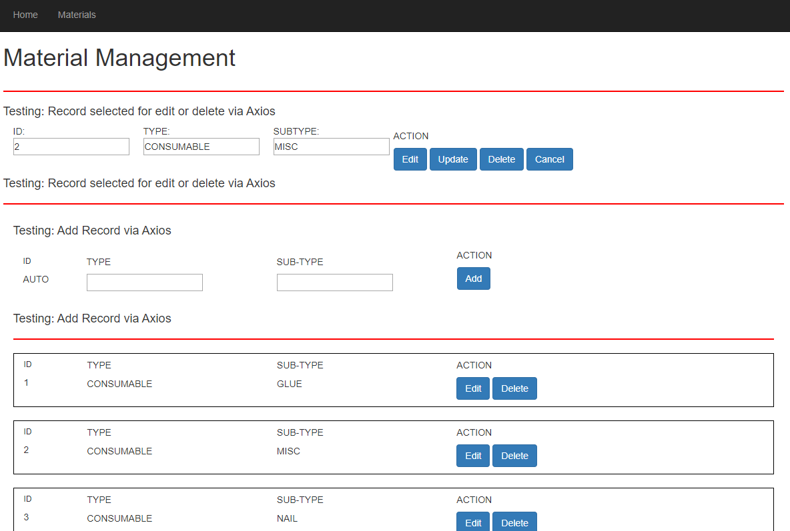

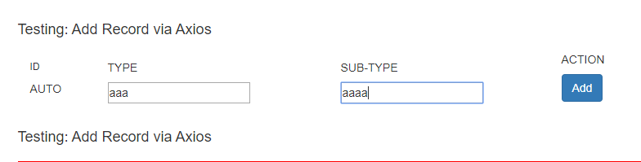

A new record can be added to the database.

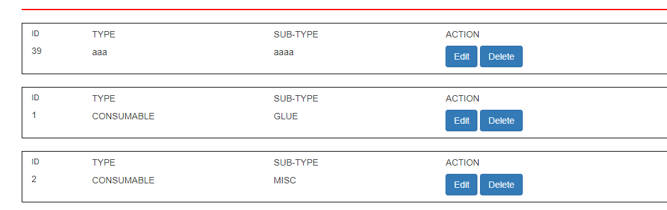

Javascript code has been added to affect the visibility of record buttons.

When the edit button is pressed…



The buttons that are available change.

When the delete button is pressed…



The buttons that are available change.

These features are testable on <http://annorumsupra.gossdouglas.com/Material>